RIVER CLEAN UP PROJECT BY WALTER BAMIDELE OLATUNJI FOUNDATION

Our rivers, especially in Africa are choking on plastic. A staggering eight million metric tons wind up in oceans every year and unraveling exactly how it gets there is critical. A recent study estimates that more than a quarter of all that waste could be pouring in from just 10 rivers, significant of them in Asia while the rest is from Africa.
“Rivers carry trash over long distances and connect nearly all land surfaces with the oceans,” making them a major battleground in the fight against sea pollution, explains Christian Schmidt, a hydrogeologist at the Helmholtz Center for Environmental Research in Leipzig, Germany.
Schmidt and his colleagues dug up published data on the plastic concentration in 57 rivers of various sizes around the world. These measurements included bottles and bags, as well as microscopic fibers and beads. The researchers multiplied these concentrations by the rivers' water discharge to calculate the total weight of plastic flowing into the sea. They then fed these data into a model that compared them with the estimated weight of plastic litter generated per person per day along each river. River Niger is a major river in Nigeria and contributed significantly to the water resources development in Nigeria. Nigeria is at the downstream of the Niger River making it to be at the receiving ends of both the goods and the bads. Pollution, Flooding and Siltation are among the bads. Plastic and other waste solids in the river channel is becoming alarming.
Walter Bamidele Olatunji Foundation has joined other environmentalist in the region to reduce these menaces in our local river networks that form the tributaries of Niger River in Nigeria catchment area. Pictures below shown some of our activities in this aspect.

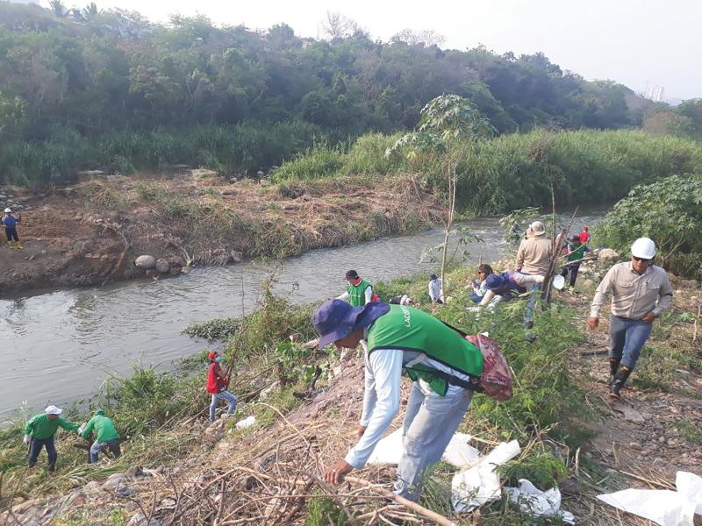
DOWNSTREAM OF USUMA RIVER BEING CLEAN UP BY WALTER BAMIDELE OLATUNJI FOUNDATION

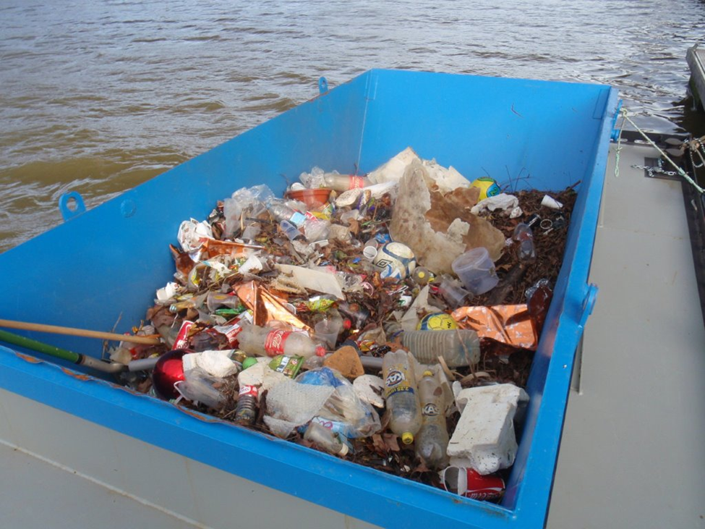
CLEAN UP BY WALTER OLATUNJI FOUNDATION AT THE SOKOTO RIVER DOWN STREAM OF RIVER NIGER AT NIGERIA PORTION OF THE BASIN

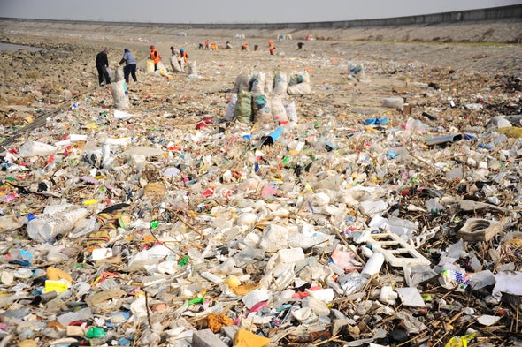

CLEANING UP OF TRIBUTARY OF RIVER SOKOTO AT THE LOWER END OF RIVER NIGER DURING THE DRY SEASON REALLY HELP TO MAKE THE RIVER HEALTHY BEFORE THE ONSET OF RAINING SEASON IS A MAJOR CONCERN FOR PLASTIC AND SOLID WASTE REDUCTION.
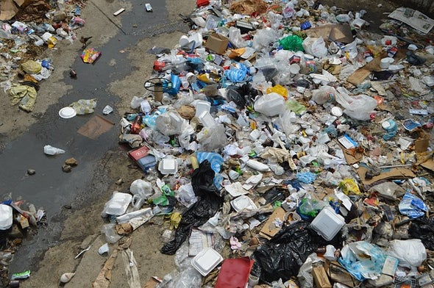
USUMA RIVER IN ABUJA WITH PLASTICS AND SOLID WASTE BEING DUMPED BY THE INHABITANTS OF MPAPE ABUJA IS WORRISOME.

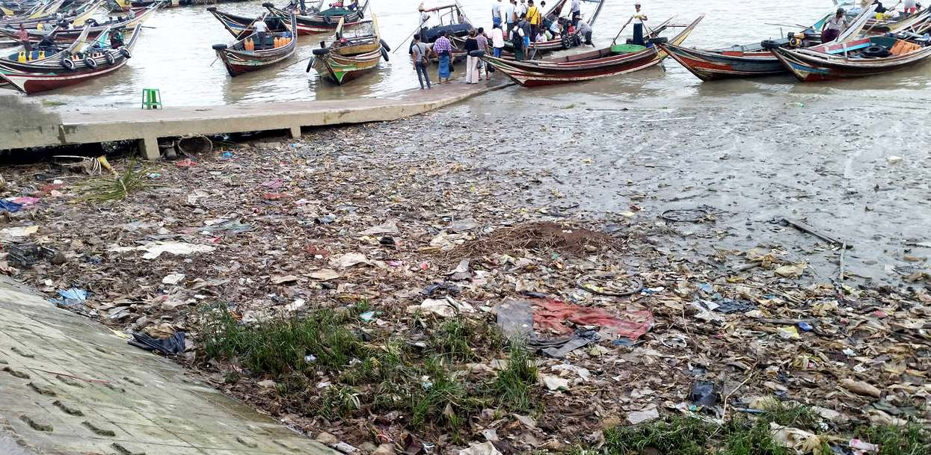
IMO RIVER: FISHING IN THIS RIVER IS GREATLY IMPARTED BY THESE RIVER POLUTION WHICH IS NOT HEALTHY FOR THE FISHES AND HUMAN CONSUMPTION.

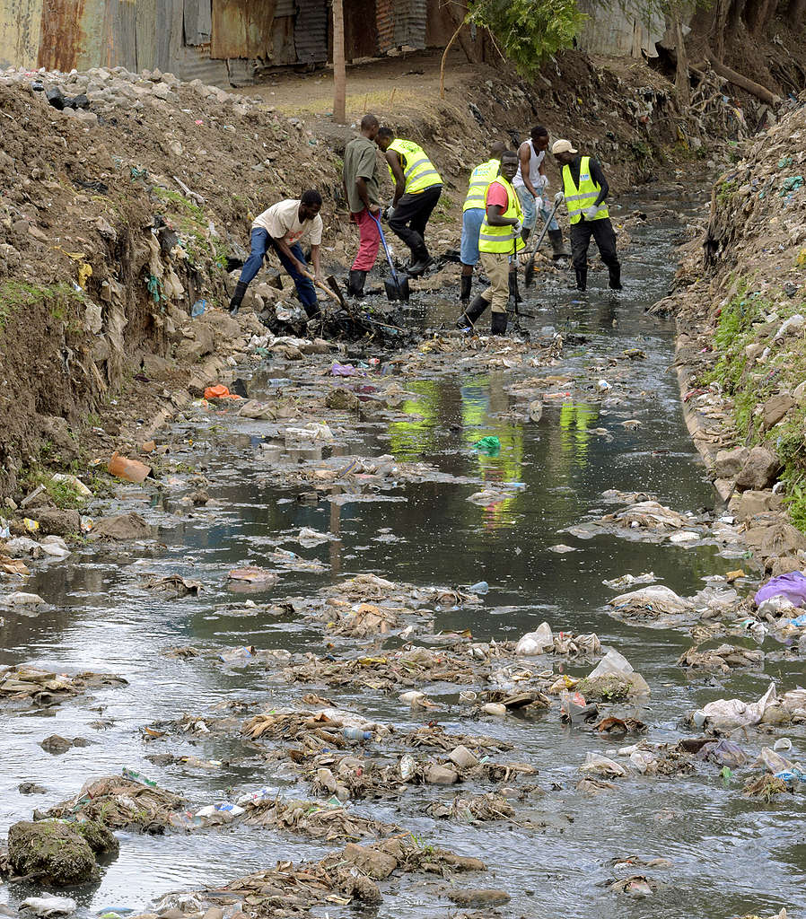

COMMUNITY DEVELOPMENT EXERCISE AT IKORODU, LAGOS STATE BY THE FOUNDATION TO CLEAN UP THE DRAINAGE AND REDUCE FLOODING.

